



|  |  |
| --- | --- |
| **Student Name** | **Om Atul Mahadeokar** |
| **SRN No** | 202200340 |
| **Roll No** | 17 |
| **Program** | Computer Engg. |
| **Year** | Third Year |
| **Division** | B |
| **Subject** | Computer Network Laboratory (BTECCE21506) |
| **Assignment No** | 1 |



**Title :** Installation and configuration of DHCP server for Linux/Windows.

**Problem Statement :** Configure a server with Dynamic Host Configuration Protocol (DHCP). Connect different nodes with DHCP server and show that all nodes configure with DHCP.

# Theory :

DHCP stands for Dynamic Host Configuration Protocol. It is the critical feature on which the users of an enterprise network communicate. DHCP helps enterprises to smoothly manage the allocation of IP addresses to the end-user clients’ devices such as desktops, laptops, cellphones, etc. is an application layer protocol.

DHCP helps in managing the entire process automatically and centrally. DHCP helps in maintaining a

unique IP Address for a host using the server. DHCP servers maintain information on TCP/IP

configuration and provide configuration of address to DHCP-enabled clients in the form of a lease.

# How DHCP works

DHCP runs at the application layer of the TCP/IP stack. It dynamically assigns IP addresses to DHCP clients and allocates TCP/IP configuration information to DHCP clients. This information includes subnet mask information, default gateway IP addresses and domain name system (DNS) addresses.

DHCP is a client-server protocol in which servers manage a pool of unique IP addresses, as well as information about client configuration parameters. The servers then assign addresses out of those address pools. DHCP-enabled clients send a request to the DHCP server whenever they connect to a network.

Clients configured with DHCP broadcast a request to the DHCP server and request network configuration information for the local network to which they're attached. A client typically broadcasts a query for this information immediately after booting up. The DHCP server responds to the client request by providing IP configuration information previously specified by a network administrator. This includes a specific IP address, as well as a time period -- also called a lease -- for which the allocation is valid.

When refreshing an address assignment, a DHCP client requests the same parameters, but the DHCP server may assign a new IP address based on policies set by administrators. DHCP clients can also be configured on an Ethernet interface.



# DHCP SERVER with two ethernet Port

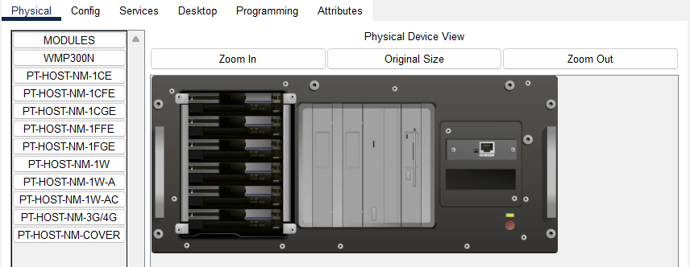

DHCP SERVER with two ethernet ports, one port for LAN service and another for WAN connectivity.

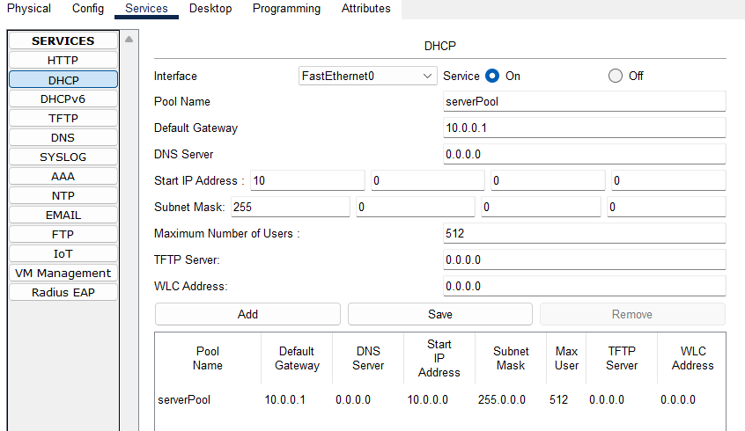

# Figure :DHCP service configuration

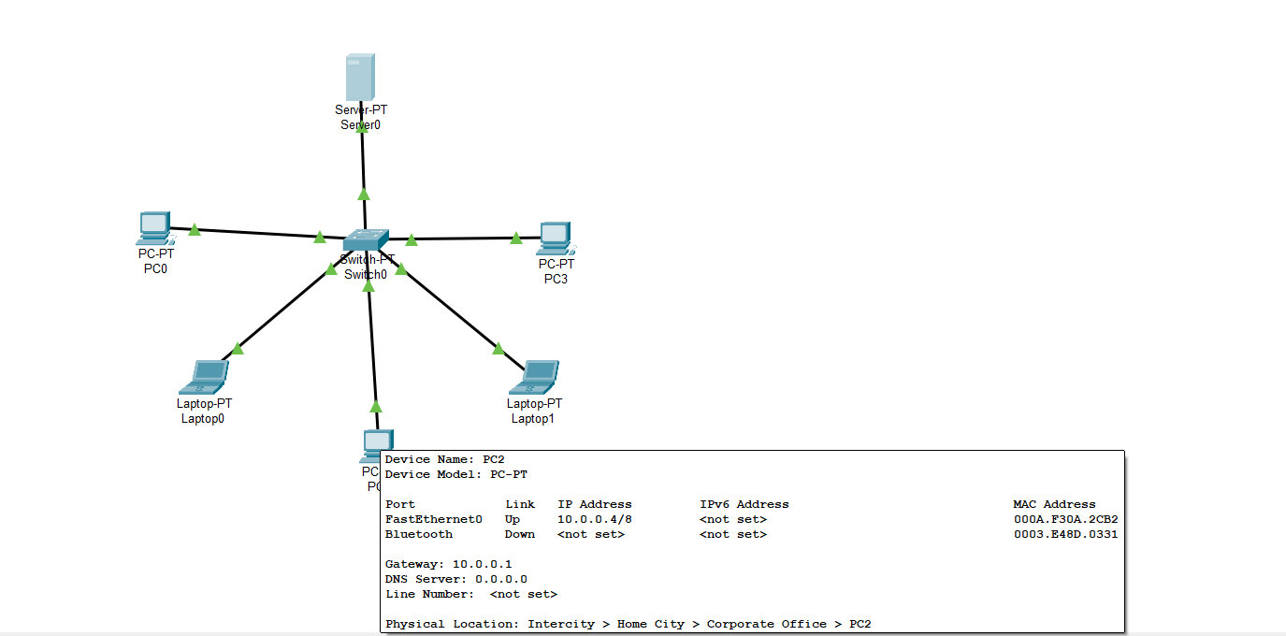

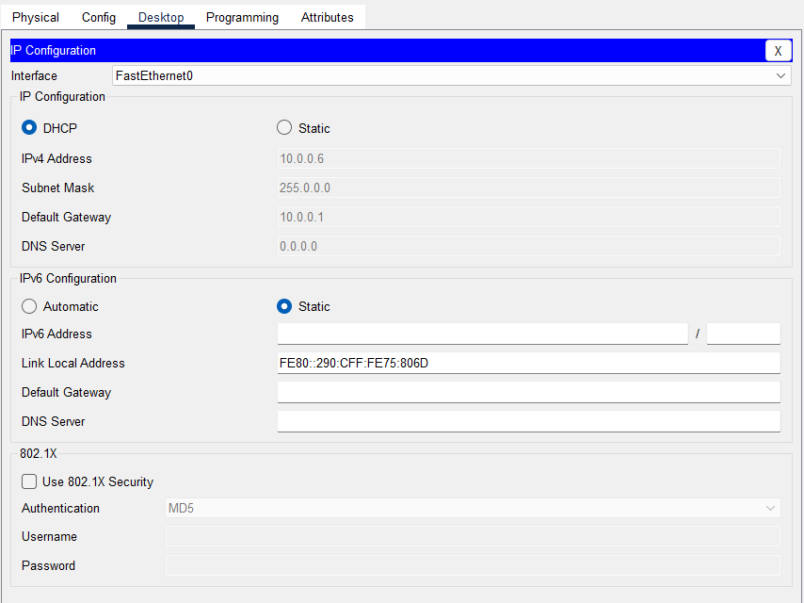

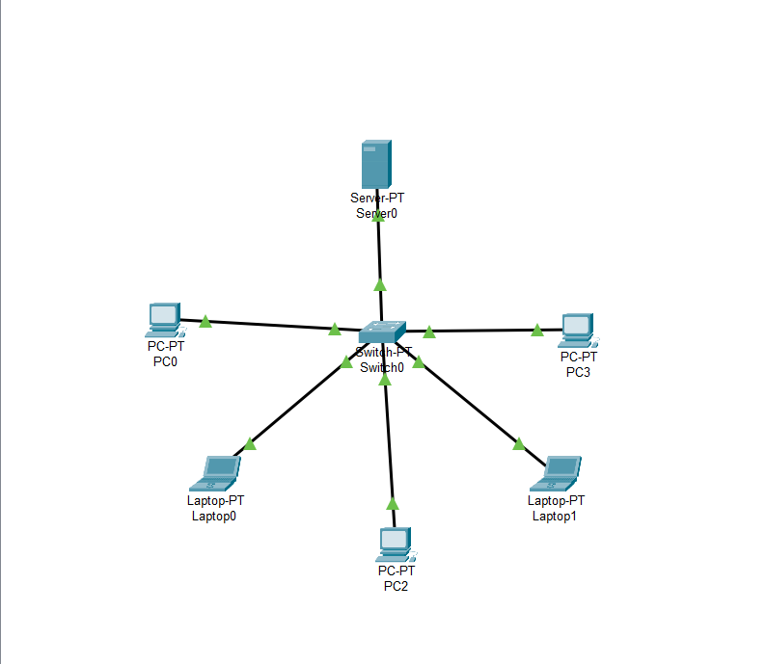

**Conclusion :**

Installing and configuring a DHCP server on Linux or Windows taught me how DHCP automates IP address allocation, simplifying network management and reducing manual effort. I learned the differences between configuration approaches on Linux (command-line) and Windows (graphical interface) and the importance of defining address pools and lease settings. Additionally, setting up failover and static IP reservations highlighted the need for reliability and customization. This experience enhanced my understanding of DHCP’s role in efficient and dynamic network operations.